**Final Project- INFO 5100**

**MedTech Health Care System**

**Team Members:**

* Anjali Sajeevan – NUID 001563277
* Manasa Bhat – NUID 001032278
* Sayali Chaudhary – NUID 001000217

**Problem Statement and Project Overview:**

* Health care system is an integral part of our life.  Patients being the major consumer in the system, they deal with lot of problems while visiting the hospital, getting lab test reports, procuring medicines and have a separate hazzle behind getting the insurance claims for these requests.
* There is a need in healthcare where there is a single stop for patients to place all their healthcare requests, track all their records and in turn help hospitals to diagnose them better.
* With the recent COVID - 19 outbreak, we all are well aware how important it is to proactively analyze the health risks and medical developments in the community.
* The purpose of MEDTECH healthcare system is to ensures that all aspects of healthcare come together in one domain to make patients life easier.
* It links the insurance to the patient; the insurance claim process is done automatically.
* It also helps to track and facilitates new drugs, test the drugs and attain FDA approval. Once approved it sends it to the drug manufacture enterprise to be mass produced and be available in the pharmacy.

**Proposed Solution:**

* This application is an improved tracking of the healthcare system that will save you a lot of time and resources for all the entities involved in the system.
* This will help in proactive monitoring and analysis of this system which eventually help in improving the health conditions and prevent or foresee an epidemic condition.
* Each entity in our application has it own share in tracking and providing complete understanding of health risks, medicine demands and vaccine developments in the community. This system will help the health authorities to better analyze the risks and manage the health resources.

**Application key functionalities:**

1. **Main Admin**

* Create Patients
* Create Insurance companies
* Create Hospitals
* Create Pharmacy
* Create Testing/Laboratory
* Create Vaccine Companies
* Create FDA authority

1. **Hospital Admin**

* Create Doctors
* Create Staff
* Accept appointments
* Add ventilators and check equipment status
* Add, assign patient and check if room availability.
* Emergency scenario for patient automatically room assigned.

1. **Patient Login:**

* Patient registers with the insurance company with the insurance ID. (Email)
* Insurance ID should be unique.
* Patient has to choose their primary hospital and primary doctor – in case of emergency.
* And when booking an appointment, the patient should have the flexibility to either choose primary or other hospital.

1. **Vaccine Admin:**

* Create developing vaccines
* Add vaccine trial patients.
* Check success of vaccine on patients
* Send vaccine for FDA approval .
* Once approved send to pharmacy.

1. **Insurance Admin:**

* Accept patient to the insurance – Send message to patients
* Add policies
* Add/Remove Hospitals and laboratory to the network

1. **Doctor Admin:**

* Can see appointments with patients
* Doctor can choose if the patient with appointment need to be admitted or not.
* One doctor cannot handle 2 patients at the same time.

1. **Pharmacy Admin:**

* The approved Vaccine will be automatically added it.
* Add medicine.
* And if corona +ve for patient, medicine shall be delivered.

1. **Laboratory/Testing Admin:**

* See all the appointments and accept and put results.
* If result +ve inform the primary hospital as well as the patient and pharmacy. (Email implementation)
* Add tests available.

1. **Delivery Login (Pharmacy)**

* Deliver medicine to patients

1. **Hospital Staff Login**

* Can add, update and delete hospital essentials products
* Can include count of hospital rooms

1. **FDA**

* See the vaccines above 90%
* Approve or decline the vaccine
* Approved vaccine sends to the pharmacy

1. **Drug Manufacturer**

* Produce new medicines in bulk and send samples to pharmacy
* Fulfill pharmacy medicine request.

**Advanced features used in the project:**

* Email notification
* Phone notification
* Graphs – Pie charts and bar graphs
* PDF generation
* Google maps for location.
* Calendar date choosing.

**Ecosystem Architecture:**

Object Model Diagram:

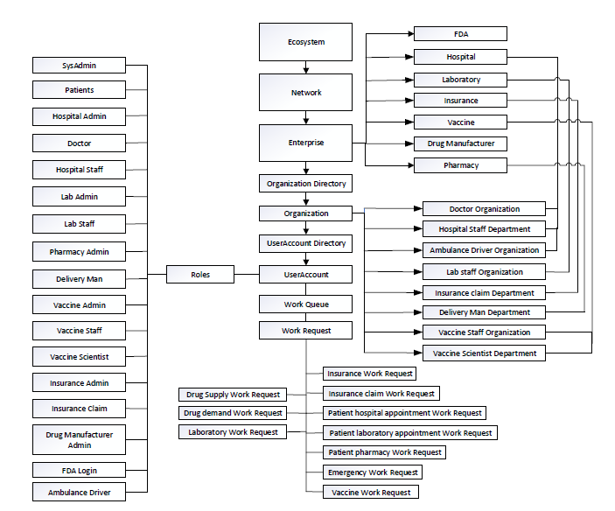

Class Diagram:

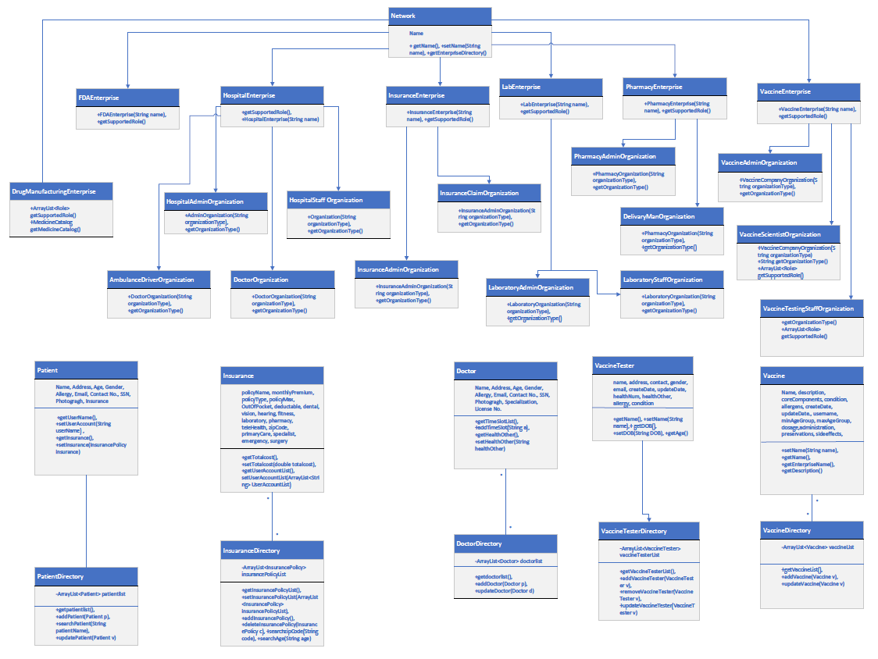

Sequence Diagram:

